13.4: (a) From the graph of its motion, the object completes one full cycle in 2.0 s; its period is thus 2.0 s and its frequency 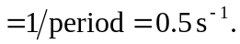 (b) The displacement varies from 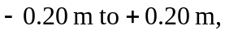 so the amplitude is 0.20 m. (c) 2.0 s (see part a)

